CS 305 Project One Template

Document Revision History

Version | Date | Author | Comments
1.0 | 3/23/2025 | Tucker Middleton

Client



Instructions
Submit this completed vulnerability assessment report. Replace the bracketed text with the relevant information. In this report, identify your security vulnerability findings and recommend the next steps to remedy the issues you have found.

- Respond to the five steps outlined below and include your findings.
- Respond using your own words. You may also include images or supporting materials. If you include them, make certain to insert them in the relevant locations in the document.
- Refer to the Project One Guidelines and Rubric for more detailed instructions about each section of the template.

Developer
Tucker Middleton

1. Interpreting Client Needs
Determine your client’s needs and potential threats and attacks associated with the company’s application and software security requirements. Consider the following questions regarding how companies protect against external threats based on the scenario information:

- What is the value of secure communications to the company?
Artemis Financial handles extremely sensitive customer information in regards to savings, retirement, and investments. Secure communication is essential to protect all of this confidential data during transmission. Without secure communication, the company risks major financial loss, company damage, and potential legal trouble.

- Are there any international transactions that the company produces?
While not explicitly mentioned, given they are a client of Global Rain, it is to be assumed that international transactions are already happening or will happen in the future.

- Are there governmental restrictions on secure communications to consider?
Yes, they must follow U.S laws like the Gramm-Leach-Bliley Act, which requires financial institutions to explain their information-sharing practices to their customers and to safeguard sensitive data. If they operate globally, other laws may apply depending on locations outside of the U.S

- What external threats might be present now and in the immediate future?
Current and future threats include unsecure API endpoints, injection attacks, vulnerable dependencies, and insecure data structures.

- What modernization requirements must be considered, such as the role of open-source libraries and evolving web application technologies?
Artemis uses a RESTful API, so the APIs must be protected against any misuse or data leaks. Modernization would require incorporating secure-by-design principles into the software development lifecycle. Open-source libraries help reduce development time but must be monitored and updated.

2. Areas of Security
Refer to the vulnerability assessment process flow diagram. Identify which areas of security apply to Artemis Financial’s software application. Justify your reasoning for why each area is relevant to the software application.

- Input Validation
  - User input would be involved in creating & managing any financial plan. Input validation allows for any malicious input, such as an SQL injection, is taken care of prior to processing.
- APIs
  - The RESTful API that Artemis Financial uses has to handle authentication, authorization, and secure data exchange. An insecure API interaction can expose sensitive information.
- Client/Server
  - The software uses a client-server architecture. If secure communication is not present, trust and data may not be protected.
- Code Error
  - Missing exceptions or traces can have major effects on showing system internals. Handling code error properly prevents sensitive information from being disclosed and helps with system health.
- Code Quality
  - Using secure coding practices, like input sanitization and least privilege principle, is some of the most important things in making strong applications.
- Encapsulation
  - Using encapsulation helps protect against unauthorized access or modifications. This is important in financial systems as exposing internal logic can lead to potential financial fraud.

3. Manual Review
Continue working through the vulnerability assessment process flow diagram. Identify all vulnerabilities in the code base by manually inspecting the code.

- Missing input validation in CRUDController.java
  - Code Line: @RequestParam(value="business_name") String name
  - The issue comes from a lack of input validation for the business_name param
  - This could lead to an attacker submitting malicious input, assumes user trust without verifying
- Unsecure SQL Connection / Poor Error Handling in DocData.java
  - Connection to an sql database is hardcoded, if anyone were to get access to the hardcoded server or the server changes, could cause many issues. Should be stored in environment variables
  - Error handling poor in code line e.printStackTrace();
  - Cryptography & Code Error Issues
- Lack of Encapsulation in customer.java
  - account_balance is package-private and not encapsulated
  - This allows external classes to modify and access account_balance, which would violate data protection principles and could lead to unauthorized changes to customer information.
- Incomplete Logic in DocData.read_document()
  - Read_document() creates a database connection but does not sanitize any inputs or properly close the connection.
  - Client/Server & Code Quality issue
- Empty Implementation in myDateTime.java
  - retrieveDateTime() and setMyDateTime() currently are just methods with no logic.
  - Code quality issue
- No Access Control or Controller Authentication
  - Public endpoints like /read and /greeting do not help in authentication or authorization checks
  - API / Client Server Issue
  - Anyone can access the endpoints, in a financial application like this, all endpoints should have role-based access to them
- Weak Object Construction
  - Constructor logic this.content2=content could use a default or overload strategy instead of having poor code leading to potential logic bugs. Similar naming could also lead to misuse of constructor.

4. Static Testing
Run a dependency check on Artemis Financial’s software application to identify all security vulnerabilities in the code. Record the output from the dependency-check report. Include the following items:

- The names or vulnerability codes of the known vulnerabilities
- A brief description and recommended solutions provided by the dependency-check report
- Any attribution that documents how this vulnerability has been identified or documented previously
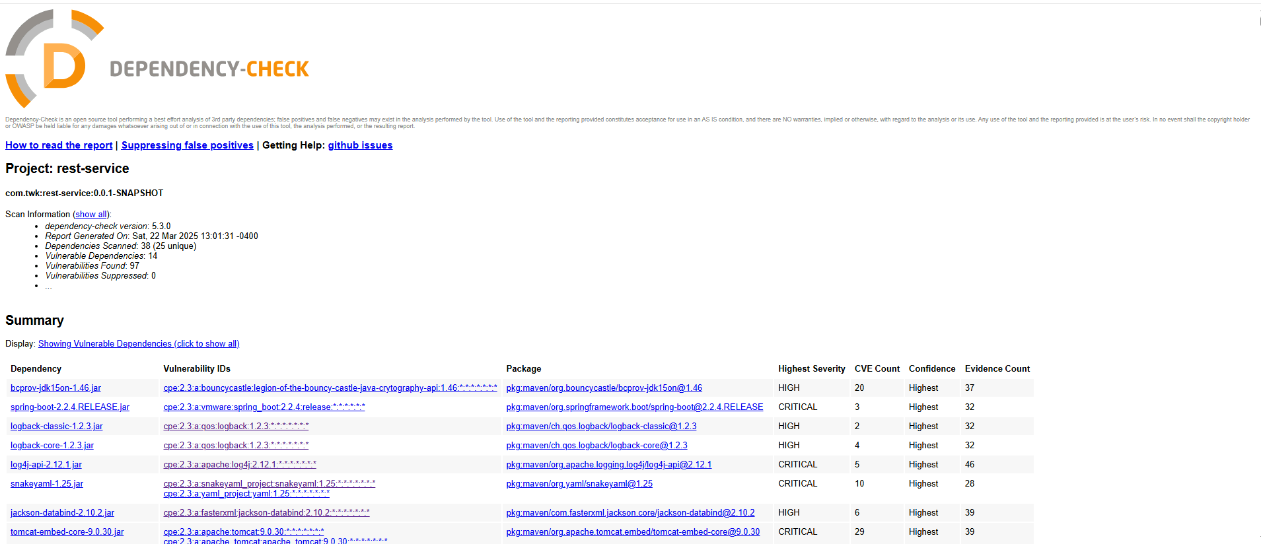

- bcprov-jdk15on-1.46.jar
  - Vulnerability IDs
  - CVE-2013-1624
  - CVE-2015-6644
  - CVE-2015-7940
  - CVE-2016-1000338
  - CVE-2016-1000339
  - CVE-2016-1000341 through CVE-2016-1000346
  - CVE-2017-13098
  - CVE-2018-5382
- Severity: High
- Description
  - This version of Bouncy Castle includes several critical cryptographic vulnerabilities including improper validation of signatures (CWE-347), weak AES implementations (CWE-310), timing attacks (CWE-361), and weak keystore integrity (CWE-354). These issues can be exploited to recover private keys, inject invisible data, or conduct side-channel attacks.
- Recommended Fix: Upgrade Bouncy Castle to version 1.65 or later
- Attribution: Documented by OWASP Dependency-Check, OSSINDEX, and RHSA advisories. Referenced in CVE records and NetApp Security Advisories

spring-boot-2.2.4.RELEASE.jar

Vulnerability IDs
- CVE-2022-27772
- CVE-2023-20873
- CVE-2023-20883
Description
- Known vulnerabilities include remote code execution and deserialization vulnerabilities.
Fix
- Upgrade to Spring Boot 2.6.6 or later
Attribution
- Identified by OWASP Dependency-Check, with CVEs publicly tracked by Spring and VMware security advisories.

Logback-classic-1.2.3.jar
CVE-2021-42550
Older versions of logback are vulnerable to improper input parsing
Upgrade to Logback 1.2.11+
OWASP Dependency-Check

Total Vulnerabilities found: 97, not all listed in Static Testing segment.

5. Mitigation Plan
Interpret the results from the manual review and static testing report. Then identify the steps to mitigate the identified security vulnerabilities for Artemis Financial’s software application.

Manual Code
Lack of Input Validation – Implement server-side validation for all query parameters
Hardcoded database credentials – Move credentials to a secure location, such as an environment variable. Use a .env or application.properties secured file
Exposed error stack traces – Use a custom error handler to log errors internally and return a generic error message to users
Poor encapsulation of customer data – Make account_balance private and provide controlled getter/setter methods
Incomplete database logic – Complete implementation with prepared statements and proper resource closing.
Unprotected API endpoints – Secure endpoints with token-based authentication, or role based authentication with Spring.
Weak Constructor logic – Refactor constructors to define expected behavior and avoid duplicated parameters

Static Test
bcprov-jdk15on-1.46.jar - Upgrade to 1.65 or higher
spring-boot-2.2.4.RELEASE.jar- Upgrade to Spring Boot 2.6.6 or higher
logback-classic/core-1.2.3.jar- Upgrade to 1.2.11 or higher
log4j-api-2.12.1.jar – Upgrade to 2.17.1 or higher
snakeyaml-1.25.jar – Upgrade to 2.0+ and validate YAML inputs

